Merrill Lynch

The Dual Listings
July 2002
EVENT DRIVEN & EQUITY ARBITRAGE SALES
FOR INTERNAL USE ONLY

Trades Examined:
UK - Netherlands
Reed Elsevier NV (REN NA) vs Reed Elsevier Plc (REL LN)
Royal Dutch Petroleum (RDA NA) vs Shell Transport & Trading Co Plc (SHEL LN)
Unilever NV (UNA NA) vs Unilever Plc (ULVR LN)

UK - Australia
BHP Billiton Ltd (BHP AU) vs BHP Billiton Plc (BLT LN)
Brambles Industries Ltd (BIL AU) vs Brambles Industries Plc (BI/ LN)
Rio Tinto Ltd (RIO AU) vs Rio Tinto Plc (RIO LN)

Introduction:
The purpose of this report is to provide a basic overview of the dual-listing environment, highlighting the nature of company structures involved, why the structures were adopted and how they work.

Contents: Page
1. Frequently Asked Questions 2
2. Why do Dual Listed Companies Exist? 4
3. Dual Listing Structures 5
4. Currency Risk 6
5. Terminology 7
6. Factors Affecting Performance 8

Appendix 1: Stock Specific Data

A.1 Reed Elsevier NV vs Reed Elsevier Plc 10
A.2 Royal Dutch NV vs Shell T&T Plc 12
A.3 Unilever NV vs Unilever Plc 14
A.4 BHP Billiton Ltd vs BHP Billiton Plc 16
A.5 Brambles Ind. Ltd vs Brambles Ind. Plc 18
A.6 Rio Tinto Ltd vs Rio Tinto Plc 20
Glossary of Terms 22

1. Frequently Asked Questions

Q. What is a dual listed structure?

Where a company is listed on two exchanges it is referred to as a Dual Listed Company. The two listed organizations have entered into profit-sharing agreements with each other, and 'equalization-ratios' exist to keep the economic performances of the two stocks pegged to each other.

Q. What is an equalization ratio?

At the time the dual listed structure is created, a ratio is set to peg the economic performance of each leg against the other. This is known as the equalization ratio. For instance, in the case of Royal Dutch / Shell, holding one Royal Dutch share is economically equivalent to holding 6.95 Shell shares. This ratio will only alter if the number of shares issued of either leg alters.

Q. Why would I trade dual listed stocks?

When examining dual listed companies, we are looking to predict which line will outperform. If this is done successfully, we can either enhance returns on a single stock position, or create a hedged position between the two, looking to lock in this performance differential. Why buy Shell stock if Royal Dutch is expected to outperform in the near term with exactly the same company exposure?

Q. Why do dual listing structures exist?

Most dual listed company structures have been formed by way of a synthetic merger. It may be advantageous for merging companies to adopt such a structure rather than follow traditional merger procedures. This may be down to factors such as tax, competition laws or shareholder approvals required. By keeping the two listed companies separate, yet forming agreements to share profits etc, many of these potential problems can be avoided. Section 2 of this report covers this topic in more detail.

Q. Are the two lines of share fungible?

No. In all six trades listed above, the two lines of stock cannot be transferred into the other. This is different from other dual listed structures, for example HSBC (London & Hong Kong).

Q. What is my exposure?

By opening a long position in one leg and a short in its sister stock an investor has hedged out any exposure to the company itself. The only exposure remaining is that inherent between the two listings, for example geographical risk. It should also be noted that index risk, whereby one stock is in one set of indices, the other in another set, also remains. This has been particularly pertinent recently with the removal of Royal Dutch and Unilever NV from the S&P 500 index.

Q. Do I have to hedge out cross currency risk?

Yes. Trading two stocks, which are listed in different currencies, will always leave the investor exposed to FX rate changes. It is therefore important to hedge out this exposure by simultaneously trading the appropriate currency position . This is covered in more detail in section 4.

Q. How do 1 trade the London / Sydney pairs without incurring timing risk?

The problem stems from the Sydney and London exchanges being open at different times, there is no overlap. In the Summer, Sydney is open from midnight to 7am BST, so there is a 1 hour gap between markets. Therefore, without being able to trade both legs simultaneously, timing risk can be encountered. There are a number of common ways to reduce this.

The most common way is to execute one market at the close, and leave a WAP order in the following market. The manner in which you do this depends upon your view of the market. The Sydney market tends to follow US performance, so it is possible to watch the US in the last few hours of the day in London to try to predict how Australia will react overnight. If you believe the market will be weak, you would look to buy first and sell over the day, whereas with an expected strong market, the reverse will be true.

Obviously there are endless permutations of ways to trade these pairs, whether using opening and closing prices, or using MAP fills. Perception of market performance is key, and as long as appropriate limits are used, timing risks can be minimized.

Q. What is the best way to structure a Dual Listed Company Trade?

The most common way to set up these trades is to use dollar equivalent amounts of each stock. By being long the same value of stock that you are short, you are said to be dollar neutral. No capital is used to gain the exposure desired, and FX rates become irrelevant, assuming the appropriate currency transaction is performed.

Q. Is there a dividend risk involved?

No. Each leg will pay equivalent dividends, according to the equalization ratio in place. Assuming you have structured the trade as dollar neutral, the dividends you will receive from the long side will be equivalent to those payable on the short side.

Q. Are there any hidden costs?

No. Apart from the normal costs of trading, there are no hidden charges for setting up trades of this nature. There is nothing more to it than selling one stock and buying another.

2. Why do Dual Listed Companies Exist?

A Dual Listed Company "merger" is actually best described as a synthetic merger. It may be advantageous to the parties concerned to link their operations contractually, whilst retaining their separate identities with separate stock exchange listings.

There are a number of key factors that may lead to a pair of companies adopting a dual listed structure rather than following the normal course of a full merger, and we can briefly cover some of the main topics below. It should be noted that this is by no means an exhaustive list.

Capital Market Access:
Liquidity provided by multiple listings, and the ability to attract domestic investors in multiple markets is an obvious attraction.

Taxation
Minimizing capital gains taxes, securing tax efficiency of future dividends and generally ensuring the tax efficiency of the firm's structure may be a great incentive.

Shareholder Approval
Most public deals require a level of shareholder approval, and the choice of structure may have some bearing on the level required. A good example of this was in the case of Reed Elsevier, where a dual listed company structure meant only a simple majority was required to pass the action. Under UK law, the acquisition of Reed by Elsevier would have required in excess of 90% acceptances,

Regulatory Consents
"Mergers" by way of a dual listed company structure are currently exempt from the UK Takeover Code. The basic premise has been that dual listed company transactions are not subject to the Code as they do not involve a change in the relevant company ownership. Although this is currently under review, it is obvious that if there is concern that violating the code will break a deal, there is a significant incentive to create a dual listed company.

Corporate Governance
With cross border deals it is very likely that culture differences will exist between the two firms, as well as differing views on how to manage the combined business. Maintaining both national identities allows these cultures to remain, whilst establishing the same long-term goals.

Reduced Flowback
In a traditional merger situation we would see the target stock de-listed from its indices upon completion of the transaction, This would obviously lead to selling pressure on the stock from index funds. We would also see flowback in the new post-merger company, again leading to selling pressure. A takeover by a foreign firm could see a target lose its domestic investor base, which is obviously not ideal. A dual listed structure would avoid these effects. This was the main reason that BHP Billiton followed the dual listed route.

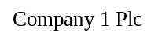
3. Dual Listing Structures

There are two common forms of DLC structure, which cover all of the above trades. The arrangements for each example are set out in the Articles of Association, written at the time of the merger.

Type 1: Combined Entities

Firstly we have arrangements akin to Royal Dutch / Shell and Reed / Elsevier, where there is a transfer of assets into a new subsidiary, which is owned by the two listed MC partners. Ownership of this new body is split according to the relative assets contributed by each party. The main function of the listed firms is to receive dividends from the subsidiary which are in turn passed on to their own shareholders.

Combined Group
Company 2 NV
Company 1 Plc
Shareholders
Shareholders

Figure 1: Dual Listing Single Entity Structure

Type 2: Separate Entitles

The second common MC structure, as seen in BHP Billiton, involves no transfer of assets. Instead, assets are shared through contractual arrangements. This ensures that shareholders have the same economic interest in the combined group; dividends are equalized so shareholders are in the identical economic position as if they held shares in a single
company. There is commonly a single electorate comprising shareholders from each group, which consider matters affecting the combined enterprise. The boards of each firm are identical, to ensure an identical business strategy prevails.

Operations
Operations

Equalization
Company 4 Ltd
Company 3 Plc
Agreement

Shareholders
Shareholders

Figure 2: Dual Listing Separate Entities Structure
4. Currency Risk

When trading a stock listed in one currency against another denominated in a second currency, it is important to hedge the currency risk created. We do not want any profits we make from the stocks to be negated by losses in the currency market. This is best demonstrated by means of a case study:

Case Study: Create Trade to become long 10 shares of Rio Tinto London,
short 10 shares Rio Tinto Sydney.
We have GBP 1000 in the bank.

N.B. In putting this trade on, we are expecting Rio Tinto Plc (London) to outperform Rio Tinto Ltd (Sydney).

Before we deal, our base position is solely GBP (in which we report PIL), so we are not exposed to any currency performance. This is the ideal currency position, which we wish to maintain. We will consider each leg of the above transaction in turn, examining its impact on our currency position.

Stage 1: Purchase of 10 shares of Rio Tinto London (Price: GBP 11. 11)

Quite simply, all we do is exchange f I 11. 10 of cash for 10 shares of Rio Tinto Plc. Our positions are now:

Bank | GBP 888.90
Stock | Long l0 Rio Tinto Plc

We are still denominated in GBP, so we need no corresponding FX transaction.

Stage 2: Sale of 10 shares of Rio Tinto Sydney (Price AUD32.08)

We exchange 10 shares of Rio Tinto Ltd for AUD320.80. This means our positions are as follows:

Bank | GBP 888.90  AUD 320.80
Stock | Long 10 Rio Tinto Plc  Short 10 Rio Tinto Ltd

We now hold a position in the Australian dollar. Should the Australian dollar underperform the Pound, we will lose money on this currency position. We need to remove this exposure to perfect the trade.

Stage 3: Sale of AUD320.80 into GBP (FX rate 2.8875)

We enter into the FX market to sell AUD320.80 into Pounds. We receive GBP 111. 10 in exchange for our Australian dollars. We now have the following positions:

Bank | GBP 1000
Stock | Long 10 Rio Tinto Plc  Short 10 Rio Tinto Ltd

Basically, in stages 2 and 3, we performed two transactions,

10 Shares Rio Tinto Ltd + GBP 111.10
+ AOD 320.80 and - AUD 320.80

adding these two together means the AUD positions negate themselves, giving:

10 Shares Rio Tinto Ltd

+ GBP 111.10

It is almost as if we have sold the Rio Tinto Ltd in exchange for GBP.

Final Position

Because the stocks were trading at parity, we have exactly the same money in the bank as we started with. We have sold exactly the same value of stock as we bought. If all three stages were performed simultaneously, it would seem to an outsider looking in that we were selling Rio Tinto Ltd in Pounds, and using those exact same Pounds to buy Rio Tinto Plc. He would never see us exposed to the Australian Dollar, despite investing in an Australian based stock.

As is the case at the beginning of the trade, we have positions only in GBP, and no exposure to other currencies, so the performance of our trade will depend solely upon the performance of Rio Tinto Plc relative to Rio Tinto Ltd, regardless of any currency movements. There is now no currency exposure.

General Rule
As a general rule of thumb, when buying a stock to settle in a different currency, you must buy the base currency of the stock, versus selling the desired settlement currency. For a sale of such stock, the reverse is true.

Example:
Buy UK Stock, Settle in Euros | Buy GBP | Sell EUR
Stock, Settle in Euros | Sell GBP | Buy EUR

5. Terminology

When analyzing pairs trades it is common to compare the price of one stock to that of the second in terms of a premium. If stock A were priced at $ 1.00, and stock B at $1.05, we would say that stock B is trading at a 5% premium to stock A.

Premium = (Price B - Price A)
Price A

6. Factors Affecting Performance

The main premise behind dual listed company trading is predicting which line will outperform. There are a number of key points that must be taken into account during analysis. We can consider a few of the most common points briefly.

1 . Index Exposure

Each of the above trades involves stocks with different weightings in different indices. This makes the relative weight of money benchmarked to each index an important factor when considering the relative performance of each leg of the trade. The Shell - Royal Dutch trade was a good example of this. Over 20% of RD's market capitalization was benchmarked in this manner, whereas the corresponding figure for Shell was only 9.4%. The main reason for this was the inclusion of RD in the S&P 500. Therefore, when we saw a net inflow into Equity markets it was intuitive that Royal Dutch would outperform Shell. During times of net outflows, we would expect the reverse to be true.

2. Geographical Risk
There are obvious differences between different markets around the world. The London Sydney pairs provide the best examples of this. Firstly we have an obvious timing difference between the two markets. Whereas London tends to follow closely any market movements in New York, Sydney is open at a different time of day. Therefore stocks in London and Sydney can be expected to trade differently on the back of US activity.

3. Local Markets

Again, the London / Sydney pairs highlight differences between local markets which can lead to pricing anomalies. In Sydney, Brambles makes up 1.3% of the ASX 200 index, whereas in London it only accounts for 0. 191/6 of the FTSE 100, It is the 18'h biggest Australian stock, but the 92'd largest on the London exchange. Therefore we can assume that Australian trackerfiinds pegged to the ASX200 have to hold a base amount of the stock regardless of economic performance, whereas FTSE 100 trackers can neglect it, as its performance will have little effect on their portfolio.

4. Regional Legislation

There are differing incentives globally for domestic investors to hold various lines of stock. For instance, stamp duty has been abolished in Australia, whereas it still exists in the UK. Also, there is a tax rebate on Australian dividends for domestic investors, obviously not the case for UK investors. These could lead, under certain circumstances, to differing performances between the two lines.

5. Arbitrage Effects
A good deal of arbitrage money follows these trades, and therefore many of them tend to trade around certain levels. If one stock becomes particularly overvalued, arbitrage accounts will look to short that stock, against going long its sister stock, thus bringing the pair back into line. By using a chartist approach it is possible to pick likely levels at which these accounts will become involved.

6. Regional Broker Expectations

We have seen occasions where local brokers' earning expectations for foreign stocks have differed from those covered in London. This led to differing recommendation changes locally to those made in London when actual results are announced, driving one line of stock to outperform the other.

7. Lead Stock

In most of these trades, one of the listed stocks owns a larger stake in the combined entity than the other. This means that perception can exist that to gain exposure to the combined group, the larger stock is the best means of entry. We often see the larger stock reacting more dramatically on corporate news, thus creating trading discrepancies between the two listed lines.

8. Legacy Effects from S&P500 Inclusions

It is important to remember in the Royal Dutch / Shell and Unilever trades until recently, the Amsterdam listed lines were included in the S&P 500 index. They are therefore well known stocks to US investors. The same cannot be said of their London listed sister stocks. With a much larger investor base aware of one line, we can again expect performance discrepancies between the London and Amsterdam stocks, leading to possible trading opportunities.

Appendix A: Stock Specific Data

Detailed in this appendix are the ownership structures, equalization ratios, index inclusions and historical spreads for all the trades concerned. The aim of this section is merely to provide background data to the trades, not to predict their future performance.

A.1 Reed Elsevier Plc vs Reed Elsevier NV

Reed Elsevier came into existence in January 1993, when Reed International and Elsevier contributed their businesses to two jointly owned companies, Reed Elsevier Plc, a UK registered company which owns all the publishing and information businesses, and Elsevier Reed Finance BV, a Dutch registered company which owns the financing activities.

Ownership Structure:
Shares Outstanding (m) Ownership
Reed Elsevier Plc 1260.940 50%
Reed Elsevier NV 737.569 50%
TOTAL 1998.509 100%

Table 1: Reed Elsevier ownership Structure
Source: Bloomberg 24 July 2002

Reed Elsevier Plc and Reed Elsevier NV each holds a 50% interest in Reed Elsevier Group p1c. Reed Elsevier Plc additionally holds an indirect equity interest in Reed Elsevier NV, reflecting the arrangements entered into between Reed Elsevier PLC and Reed Elsevier NV at the time of the merger in 1993. This determined the equalization ratio means one Reed Elsevier NV ordinary share is, in broad terms, intended to confer equivalent economic interests to 1.538 Reed Elsevier Plc ordinary shares. The equalization ratio is subject to change to reflect share splits and similar events that affect the number of outstanding ordinary shares of either Reed Elsevier Plc or Reed Elsevier NV.

Under the equalization arrangements, Reed Elsevier Plc shareholders have a 52.9% economic interest in Reed Elsevier and Reed Elsevier NV shareholders (other than Reed Elsevier Plc) have a 47. 1 % economic interest in Reed Elsevier. Holders of ordinary shares in Reed Elsevier Plc and Reed Elsevier NV enjoy substantially equivalent dividend and capital rights with respect to their ordinary shares.

Reed Elsevier NV
Reed Elsevier Plc
Shareholders
Shareholders
Reed Elsevier Group Plc
50%
50%

Index Inclusions:

Stock | Index | Assets  Benchmarked | Weight | Value Tracked | M/Cap | % Held by Trackers
 |  | (USD bn) |  | (USD mm) | (USD mm)
Reed Elsevier Plc | FTSE 100 | 15 | 0.68%
 | FTSE All-Share | 174 | 0.58%
 | MSCI EAFE | 180 | 0.19%
 | MSCI World | 150 | 0.08%
 | FTSE World | 100 | 0.07% | 1,630.00 | 9412.362 | 17%
Reed Elsevier NV | AEX | 5 | 3.44%
 | MSCI EAFE | 180 | 0.13%
 | MSCI World | 150 | 0.06%
 | FTSE World | 100 | 0.06% | 544.61 | 7857.239 | 7%

Table 2: Reed Elsevier Index Inclusions
Source: Merrill Lynch 24 July 2002

Historical Spread (Reed Elsevier NV as Premium to Reed Elsevier Plc)

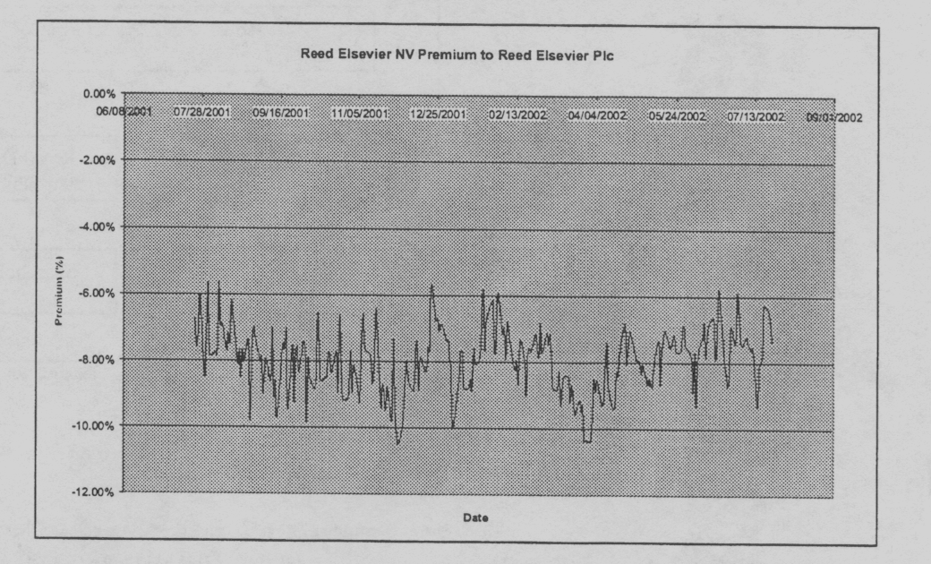

Figure 4: Reed Elsevier Historical Spread
Combined Group
Source: Merrill Lynch 24 July 2002

A.2 . Royal Dutch NV vs Shell Transport & Trading Plc

In 1907, an arrangement was formed between Shell Transport and Trading Plc and Royal Dutch Petroleum Company. Both companies' sole activities became the controlling of Royal Dutch Shell group of companies.

Ownership Structure:

Shares Outstanding (m) Profit Split
Shell T&T Plc 9733.175 40%
Royal Dutch Co 2126.648 60% 60%
TOTAL 11859.823 100% 100%

Table 3: Royal Dutch 1 Shell Ownership Structure
Source: Bloomberg 24 July 2002

The sole activity of The Shell Transport and Trading Company Plc and Royal Dutch NV is the ownership of a 40% and a 60% respective interest in the Royal Dutch/Shell Group of Companies of which they are not a part and in whose activities they do not engage.

40%
Royal Dutch Shell Group
Royal Dutch
Petroleum Co.
Shell T & T Plc
Shareholders
Shareholders
60%

Figure 5: Royal Dutch 1 Shell Dual Listing Structure

Equalization Ratio:

The equalization ratio is calculated as follows:

(Shell Shares Outstanding / Royal Dutch Shares Outstanding) * (RD Profit Split / Shell Profit Split)

(9133.175 / 2126.648) * (0.6 / 0.4) = 6.442.

Therefore:

Shell T&T Plc * (EUR/GBP) * 6.9397 = Implied Royal Dutch Petroleum Co.

Index Inclusions:
Stock | Index | Assets Benchmarked | Weight | Value Tracked | M/Cap | % Held by Trackers
 |  | (USD bn) |  | (USD mm) | (USD mm)
Shell T&T | FTSE 100 | 15 | 4.21%
 | FTSE All-Share | 174 | 3.46%
 | MSCI EAFE | 180 | 1.06%
 | MSCI World | 150 | 0.47%
 | FTSE World | 100 | 0.44% | 9,692.38 | 57,172.82 | 17%
Royal Dutch | AEX | 5 | 10.77%
 | MSCI EAFE | 180 | 1.60%
 | MSCI World | 150 | 0.71%
 | FTSE World | 100 | 0.67%
 | ESTOXX50 | 120 | 7.49% | 14,149.22 | 85,590.22 | 17%

Table 4: Shell - Royal Dutch Index Inclusions
Source: Merrill Lynch 24 July 2002

1 Year Historical Spread (Royal Dutch as Premium to Shell):

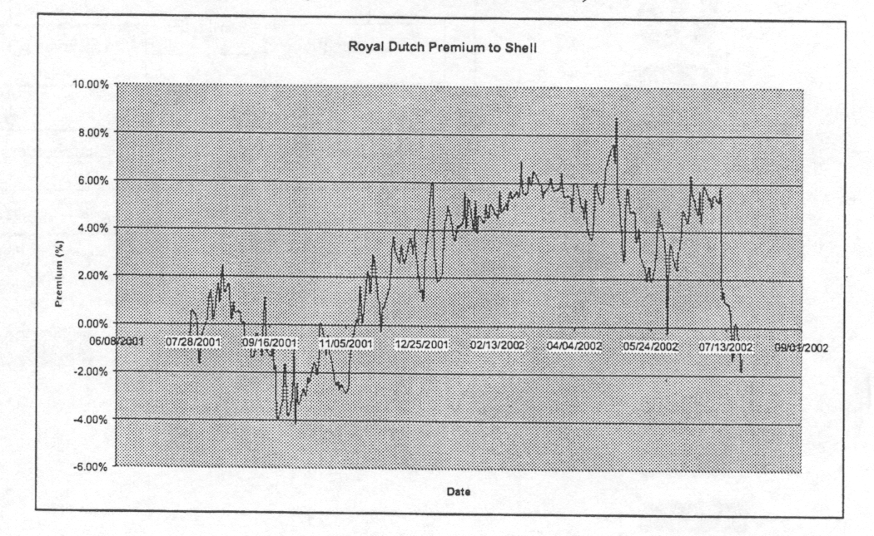

Figure 6: Royal Dutch Shell Historical Spread
Source: Merrill Lynch 24 July 2002

A.3 Unilever Plc vs Unilever NV

Unilever Plc and Unilever NV signed an equalization agreement on 28 June 1946. The two stocks have traded as a pair since then.

Ownership Structure:
Shared Outstanding (m) Ownership
Unilever Plc 2911 36.62%
Unilever NV 571.576 63.37%
TOTAL 3482.576 100%

Table 5: Unilever Ownership Structure
Source: Bloomberg 24 July 2002

Unilever consists of two parent companies, Unilever Plc and Unilever NV. The parent companies operate as nearly as practicable as a single entity. Both parent companies have the same directors and are linked through an equalization agreement.

Unilever NV
Unilever Plc
Shareholders
Shareholders
Operations
Operations
Equalization
Agreement

Figure 7: Unilever Dual Listing Structure

Equalization Ratio:

Unilever Plc * (EUR/GBP) * (20/3) = Implied Unilever NV

Index Inclusions:

Stock | Index | Assets Benchmarked | Weight | Value Tracked | M/Cap | % Held by Trackers
 |  | (USD bn) |  | (USD mm) | (USD mm)
Unilever Plc | FTSE 100 | 15 | 1.56%
 | FTSE All-Share | 174 | 1.30%
 | MSCI EAFE | 180 | 0.40%
 | MSCI World | 150 | 0.17%
 | FTSE World | 100 | 0.15% | 3,607.76 | 21,179.24 | 17%
Royal Dutch | AEX | 5 | 10.63%
 | MSCI EAFE | 180 | 0.54%
 | MSCI World | 150 | 0.24%
 | FTSE World | 100 | 0.21%
 | ESTOXX50 | 120 | 2.44% | 5,129.87 | 27,621.72 | 19%

Table 6: Unilever Index Inclusions
Source: Merrill Lynch 24 July 2002

1 Year Historical Spread (Unilever NV as Premium to Unilever Plc):

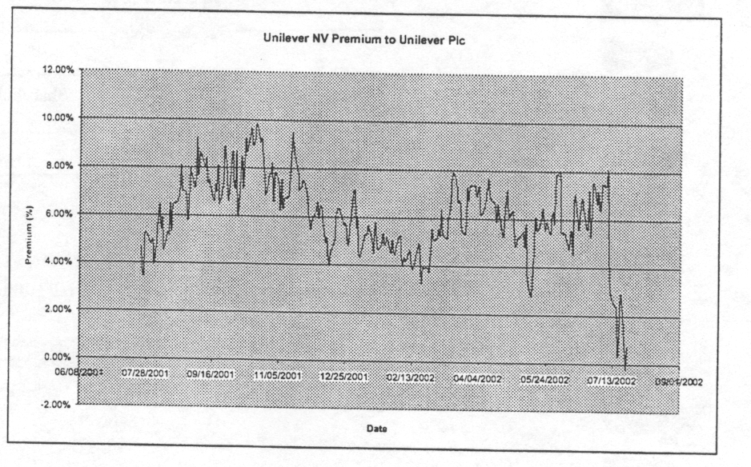
Figure 8: Unilever Historical Spread
Source: Merrill Lynch 24 July 2002

A.4 BHP Billiton Plc vs BHP Billiton Ltd

The BHP Billiton DLC was created in June 2001 when BHP Ltd acquired Billiton Plc. There is still a Johannesburg listing (BIL SJ), which trades very tightly to the London listing, and in good volume.

Ownership Structure:
Shared Outstanding (m) Ownership
BHP Billiton Plc 2467.990 36.62%
BHP Billiton Ltd 3718.264 63.37%
TOTAL 6186.254 100%

Table 7: BHP Billiton Ownership Structure
Source: Bloomberg 24 July 2002

BHP Billiton Ltd

BHP Billiton Plc
Shareholders
Shareholders
Operations
Operations
Equalization
Agreement

Figure 9: BHP Billiton Dual Listing Structure

Equalization Ratio:

There is no equalization ratio to be applied to the BHP Billiton trade. The stocks trade 1:1, Pari Passu.

BHP Billiton Plc = BHP Billiton Ltd

Index Inclusions:

Stock | Index | Assets Benchmarked | Weight | Value Tracked | M/Cap | % Held by Trackers
 |  | (USD bn) |  | (USD mm) | (USD mm)
BHP Billiton Plc | FTSE 100 | 15 | 0.78%
 | FTSE All-Share | 174 | 0.68%
 | MSCI EAFE | 180 | 0.21%
 | MSCI World | 150 | 0.09%
 | FTSE World | 100 | 0.08% | 1,886.05 | 10,804.74 | 17%
BHP Billiton Ltd | ASX | 20 | 6.06%
 | MSCI EAFE | 180 | 0.37%
 | MSCI World | 150 | 0.16%
 | FTSE World | 100 | 0.13% | 2,244.62 | 18,960.32

Table 8: BHP Billiton Index Inclusions
Source: Merrill Lynch 24 July 2002

Historical Spread (BHP Billiton Ltd as Premium to BHP Billiton Plc):

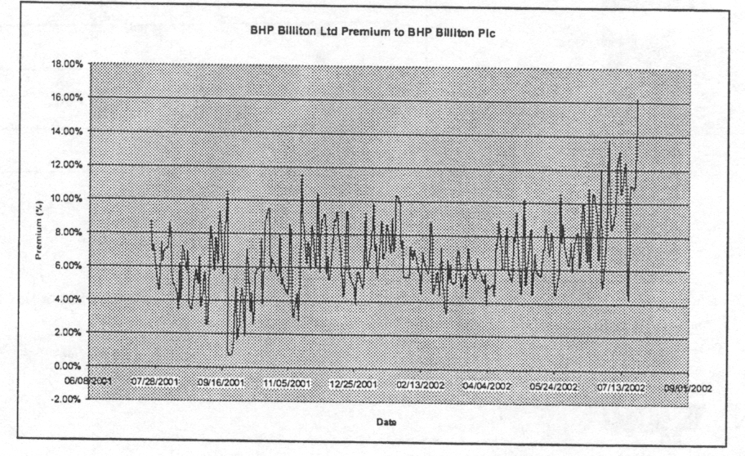

Figure 10: BHP Billiton Historical Spread
Source: Merrill Lynch 24 July 2002

BHP Billiton Ltd
BHP Billiton Plc
Shareholders
Shareholders
Operations
Operations
Equalization
Agreement
A.5 Brambles Industries Plc vs Brambles Industries Ltd

The Brambles dual listing was created on 7th August 2001 when Brambles Industries Ltd. acquired the support services activities of GKN Plc, forming Brambles Industries Plc.

Ownership Structure:

Shared Outstanding (m) Ownership
Brambles Industries Plc 966.547 57.22%
Brambles Industries Ltd 722.0 42.78%
TOTAL 1688.547 100%

Table 9: Brambles Industries Ownership Structure
Source: Bloomberg 24 July 2002

Brambles Ltd
Brambles Plc
Shareholders
Shareholders
Operations
Operations
Equalization
Agreement

Figure 11: Brambles Industries Dual Listing Structure

Equalization Ratio:

There is no equalization ratio to be applied to the Brambles trade. The stocks trade Pari Passu.

Brambles Industries Plc = Brambles Industries Ltd.

Index Inclusions:

Stock | Index | Assets Benchmarked | Weight | Value Tracked | M/Cap | % Held by Trackers
 |  | (USD bn) |  | (USD mm) | (USD mm)
Brambles Inds Plc | FTSE 100 | 15 | 0.20%
 | FTSE All-Share | 174 | 0.17%
 | MSCI EAFE | 180 | 0.05%
 | MSCI World | 150 | 0.02%
 | FTSE World | 100 | 0.02% | 469.86 | 2,666.24 | 18%
Brambles Inds Ltd | ASX | 20 | 1.32%
 | MSCI EAFE | 180 | 0.08%
 | MSCI World | 150 | 0.03%
 | FTSE World | 100 | 0.03% | 485.47 | 4,138.41 | 12%
Table 10: Brambles Index Inclusions
Source: Merrill Lynch 24 July 2002

Historical Spread (Brambles Ltd as Premium to Brambles Plc):

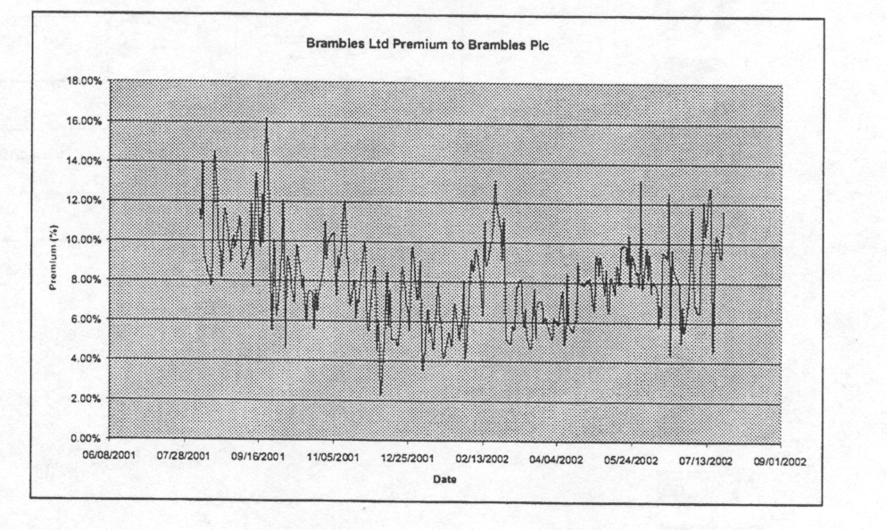
Figure 12: Brambles Industries Historical Spread
Source: Merrill Lynch 24 July 2002

A.6 Rio Tinto Plc vs Rio Tinto Ltd

The Rio Tinto Dual Listing was created in December 1995 by the "merger" of Rio Tinto Ltd and Rio Tinto Plc. At the time, Rio Tinto Plc owned a 49% stake in its Australian sister company, but this was reduced in 2000, at the request of the Australian government, to .37.6%. A share buyback and collection facilitated this reduction.

Ownership Structure:

Shared Outstanding (m) Ownership
Rio Tinto 1064.336 68.10%
Brambles Industries Ltd 311.261 19.90%
TOTAL 1536.147 100%

Table 11: Rio Tinto Ownership Structure
Source: Merrill Lynch 24 July 2002

Rio Tinto Ltd
Rio Tinto Plc
Shareholders
Shareholders
Operations
Operations
Equalization
Agreement

Figure 13: Rio Tinto Dual Listing Structure

Equalization Ratio:

There is no equalization ratio to be applied to the Rio Tinto trade. The stocks trade Pari Passu.

Rio Tinto Plc = Rio Tinto Ltd

Index Inclusions:

Stock | Index | Assets Benchmarked | Weight | Value Tracked | M/Cap | % Held by Trackers
 |  | (USD bn) |  | (USD mm) | (USD mm)
Brambles Inds Plc | FTSE 100 | 15 | 1.24%
 | FTSE All-Share | 174 | 1.04%
 | MSCI EAFE | 180 | 0.34%
 | MSCI World | 150 | 0.15%
 | FTSE World | 100 | 0.12% | 2,946.27 | 17,133.67 | 17%
Brambles Inds Ltd | ASX | 20 | 2.79%
 | MSCI EAFE | 180 | 0.11%
 | MSCI World | 150 | 0.05%
 | FTSE World | 100 | 0.04% | 862.54 | 8,738.87 | 10%

Table 12: Rio Tinto Index Inclusions
Source: Merrill Lynch 24 July 2002

Historical Spread (Rio Tinto Ltd as Premium to Rio Tinto Plc):

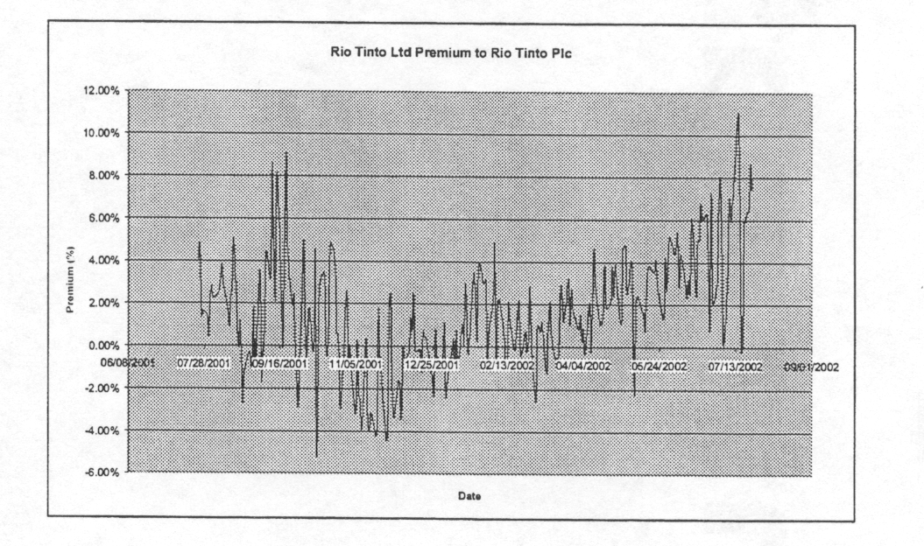
Figure 14: Rio Tinto Historical Spread
Source: Merrill Lynch 24 July 2002

Glossary of Terms:

- DLC: Dual Listed Company

- Fungible: Two lines of stock can be exchanged for each other.

- Pari Passu: The shares trade on a ratio of 1:1

